**Internet Information Services**

**Installation & Configuration**

Go to run🡺 Type servermanager.

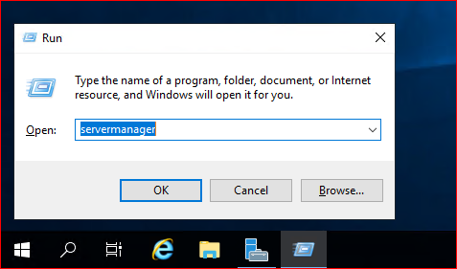

This Page will reflect

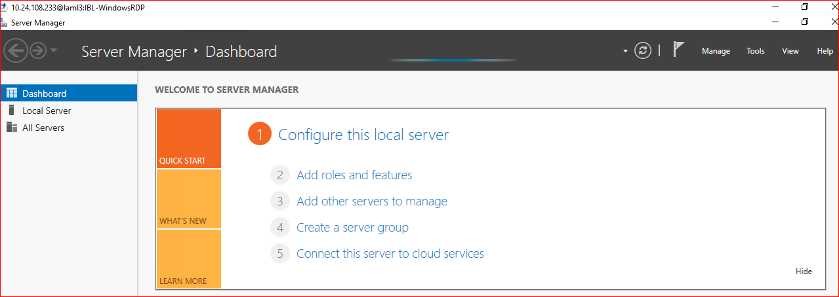

Go to 🡺 add roles and Features

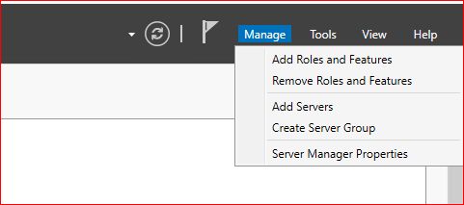

Click on Next button

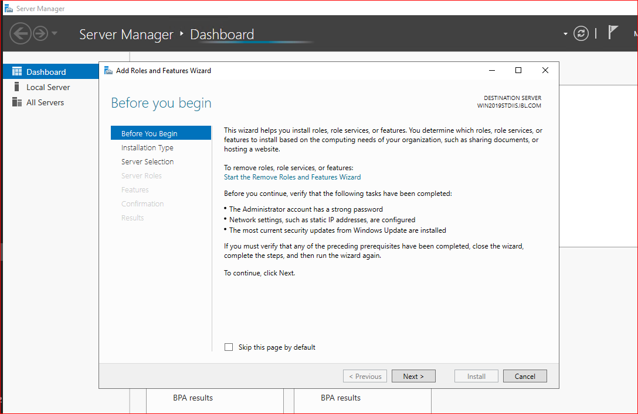

Select Role-Based or feature-based installation🡺 Next

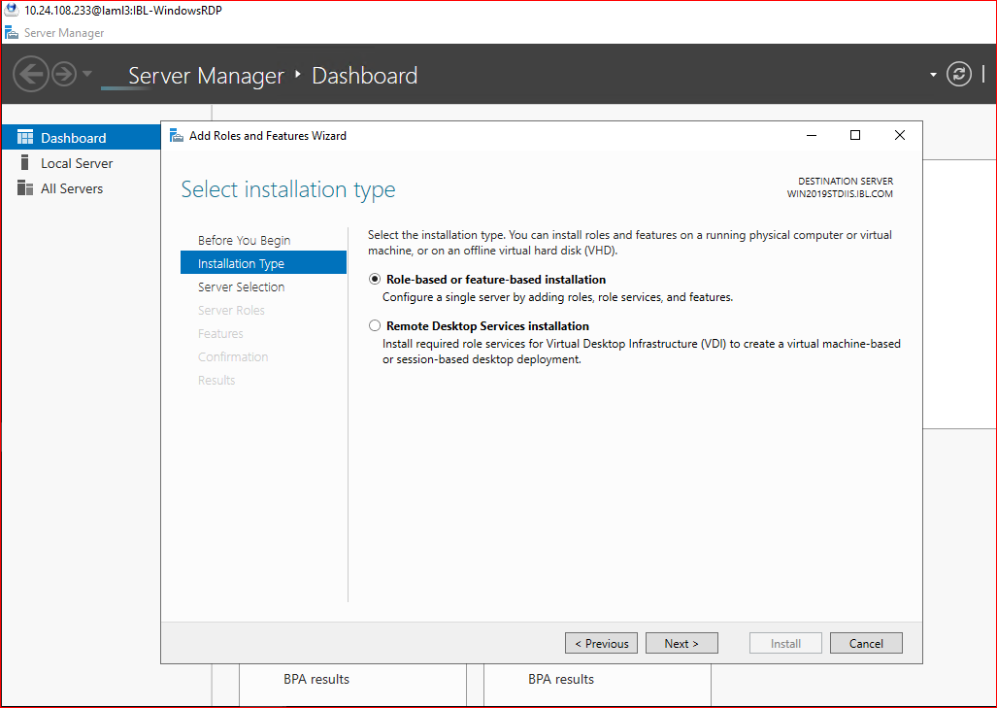

Click on Next button

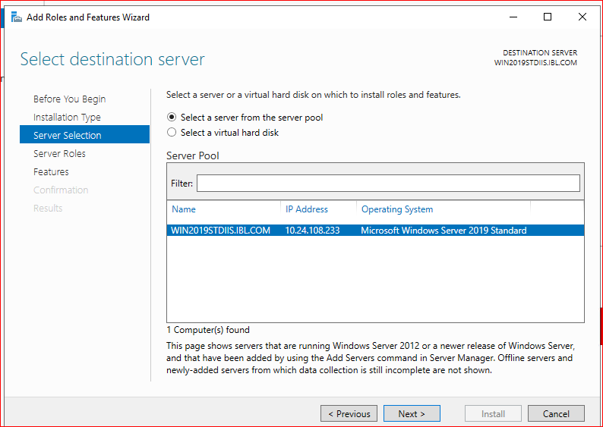

Select the respective module which is mentioned below than click on next button🡺

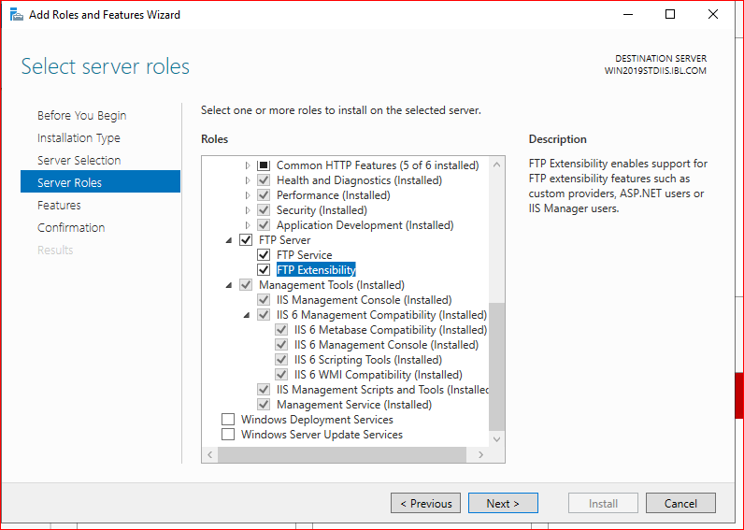

Select the below mentioned features and Next 🡺

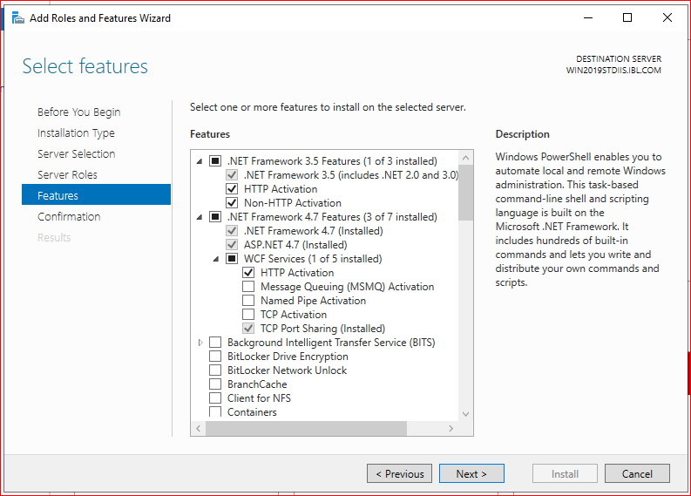

Click on🡺 Install button.

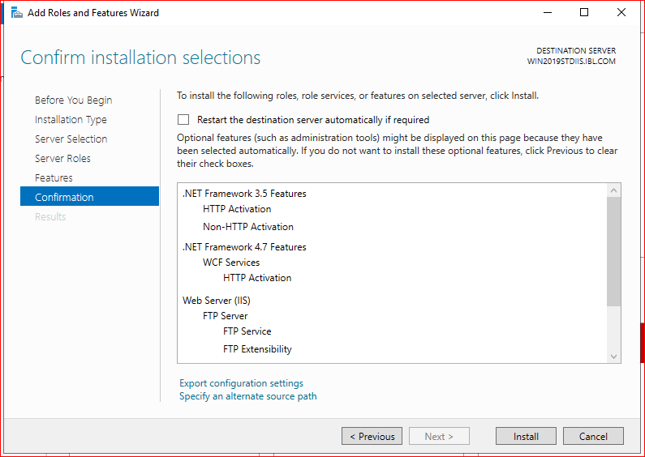

Once installation is completed Reboot the server.

